**Automation**

**USING THE SIGNATURE RECOGNITION MODEL IN GOOGE COLAB**

**To predict weather a signature is real or not given another real signature of a person, follow the following steps.**

1. Use your Gmail to open the following Colab Notebook.

<https://colab.research.google.com/drive/17Clgjs7lOpuWTHDv5m9OgF5yj-EDYzXu?usp=sharing>

1. Mount the Google drive by writing the following in a new cell.

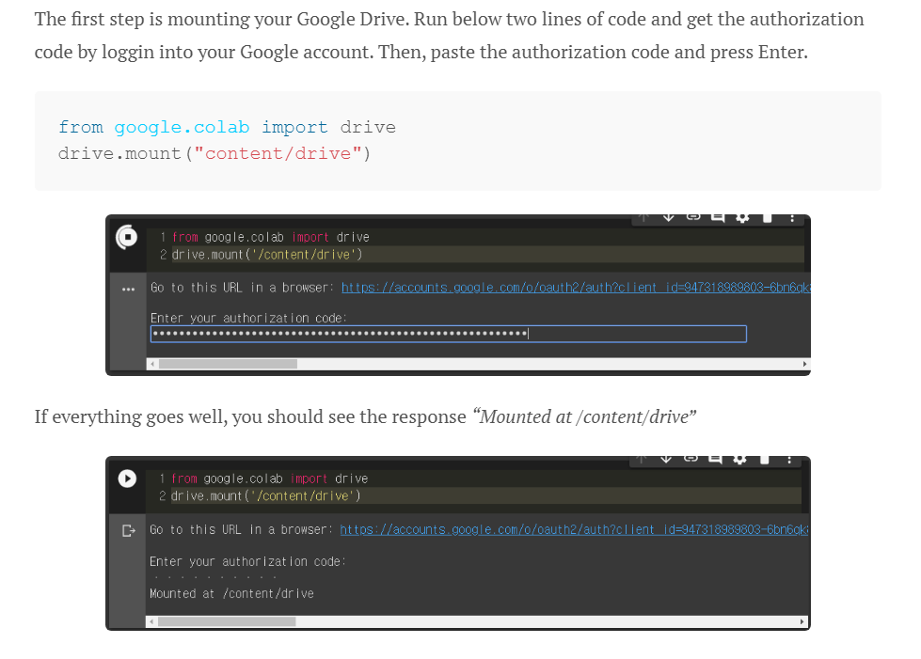

1. Download the .hdf5 file from the following link.

<https://drive.google.com/file/d/1aSO_iHJCN9YuovQRiZDgh7tzfGrVJ7yh/view?usp=sharing>

1. Put the above .hgf5 file in your Drive which is attatched to the colb
2. Run the cell marked with ##1 in the notebook.
3. Run the cell marked witj ##2 .
4. In the cell marked with ##3, replace the“/content/drive/My Drive/SOAI/Ass 2 /comparor.hdf5” with the address of the .hdf5 file uploaded by you in step 4
5. Run cell ##4
6. In cell ##5, replace “'path to the real signature image of the person'” with the path to image of real signature of the person. And “path to the image to be tested” with the path of the image of signature which is to be tested.
7. The cell will output ‘real’ , or ‘fake’ based on second image is real or forged.